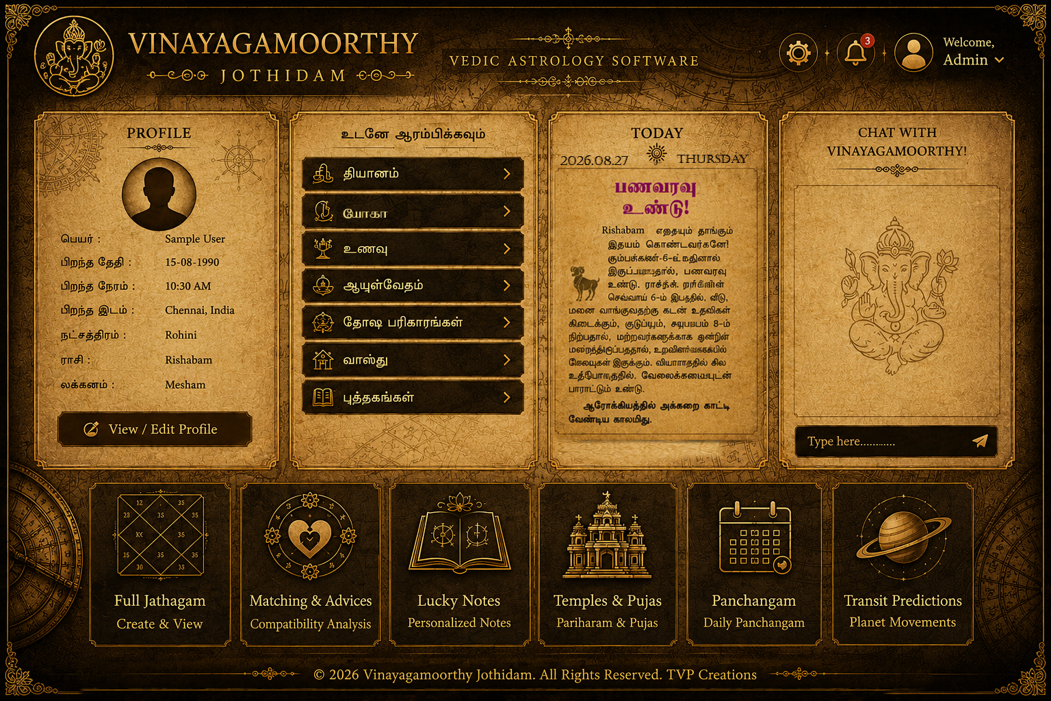
Jathagam

Analyze personal jatahgam and give the correct prediction aout this headings for each users. And very nice and perfect sentences write like a jothidar or guruji.

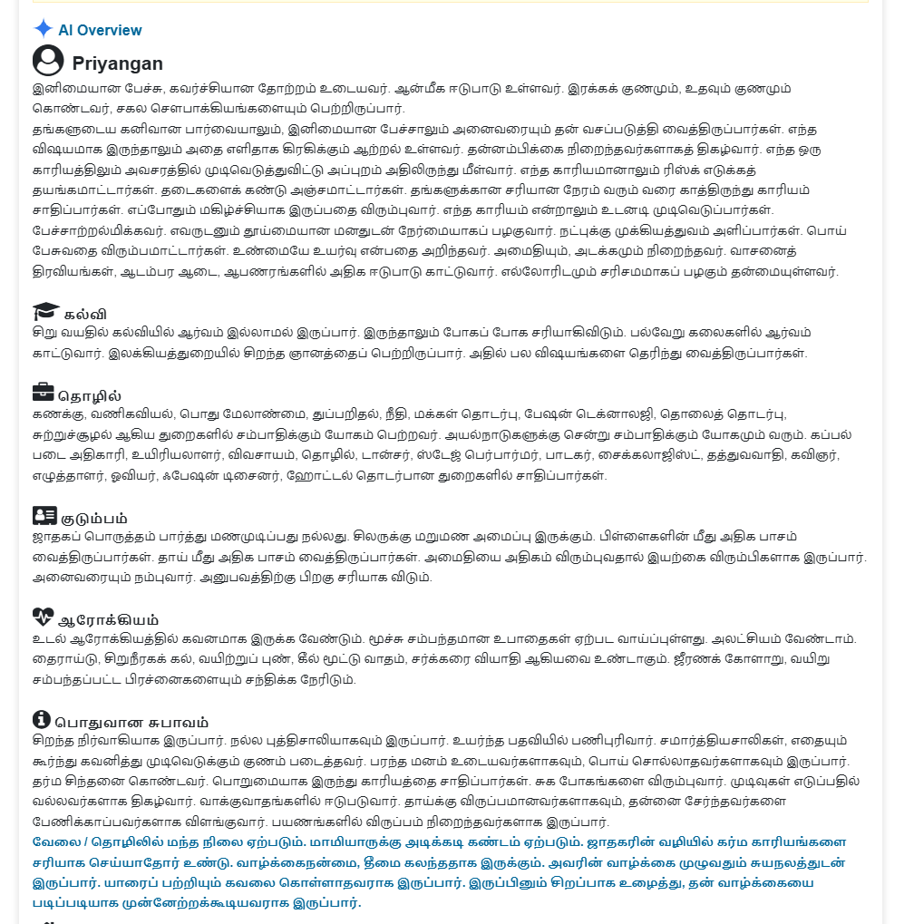

Matching
Please make a image like this but Put our website name and TVP Creations name. put the details correctly and make a professional image for matching result. If any one put the input correctly then click submit button, then this type result image needs to appear in the software, and also download button also need to put there, so user can download this image and use.

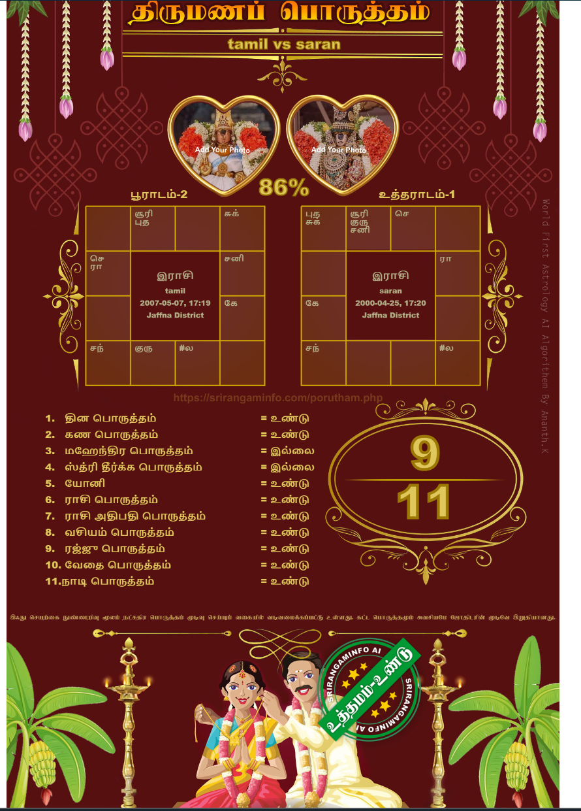

Transit prediction
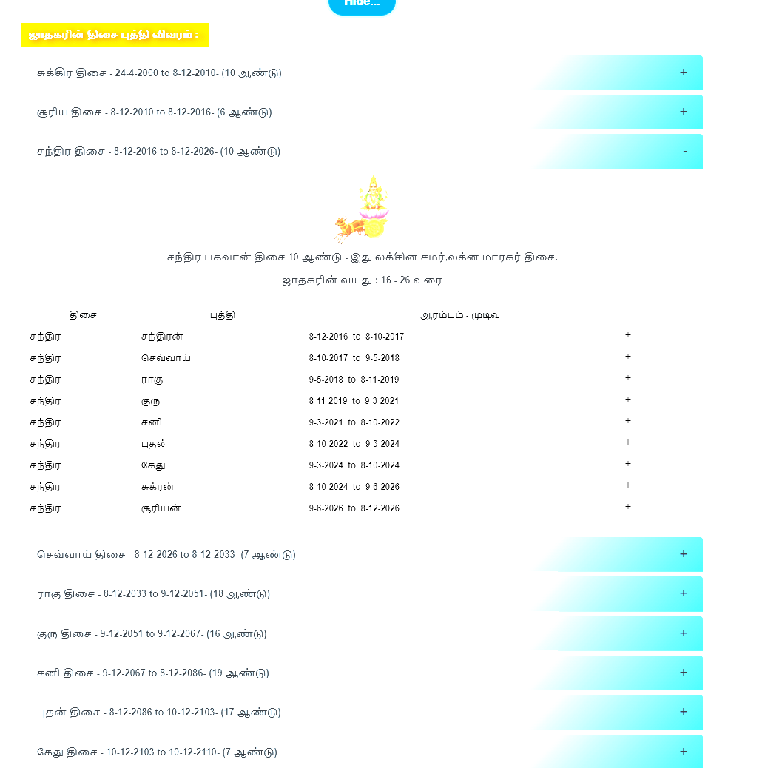

Temple and pujas
Please give to user a navakraga temples and details as a chart. You can get the datas from Wikipedia. And rewrite or make a beautiful table . give navagraga temples which is in india and give all temple time, special poojas, and other history also put the table.ok.
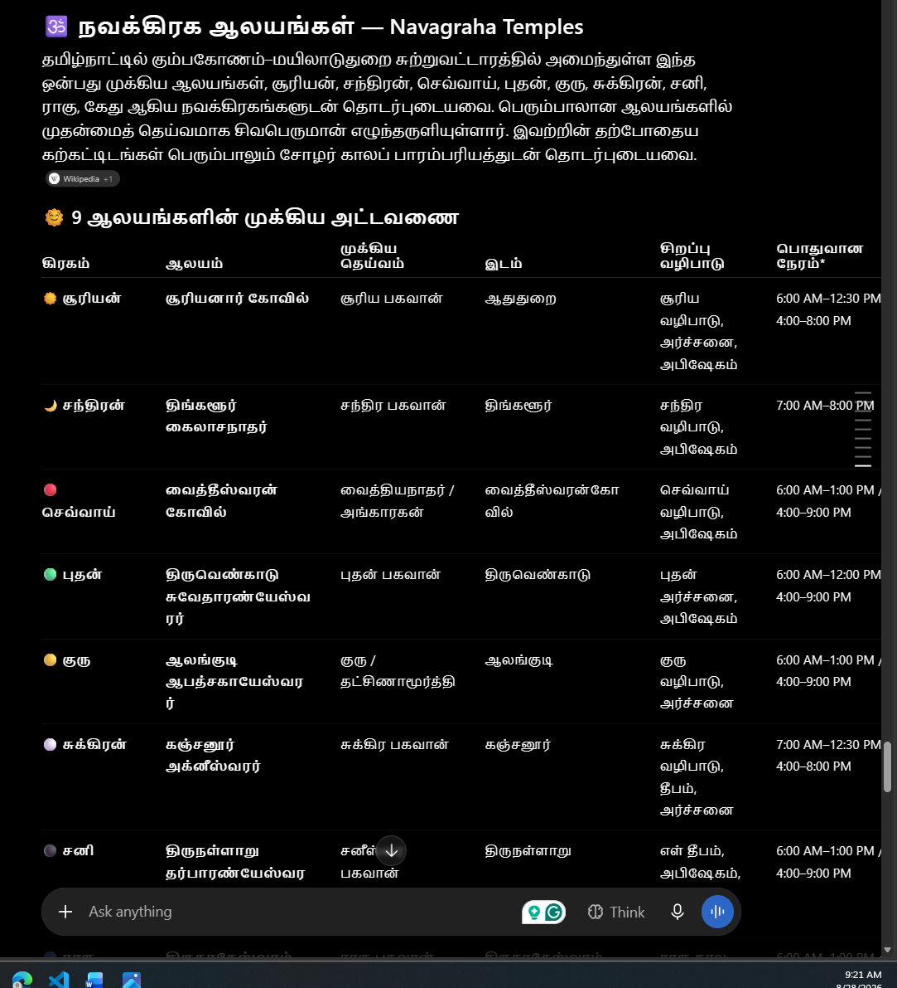

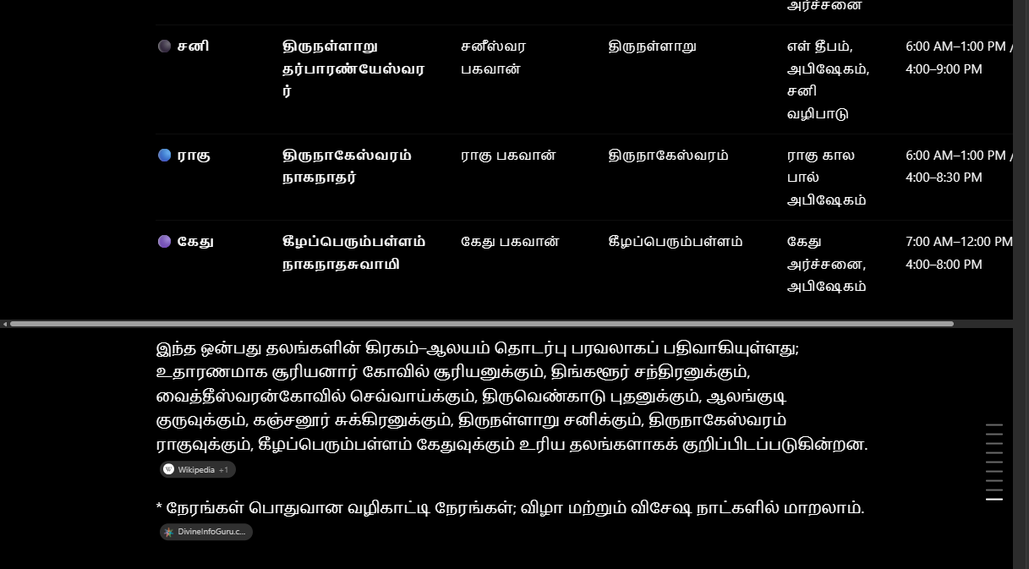

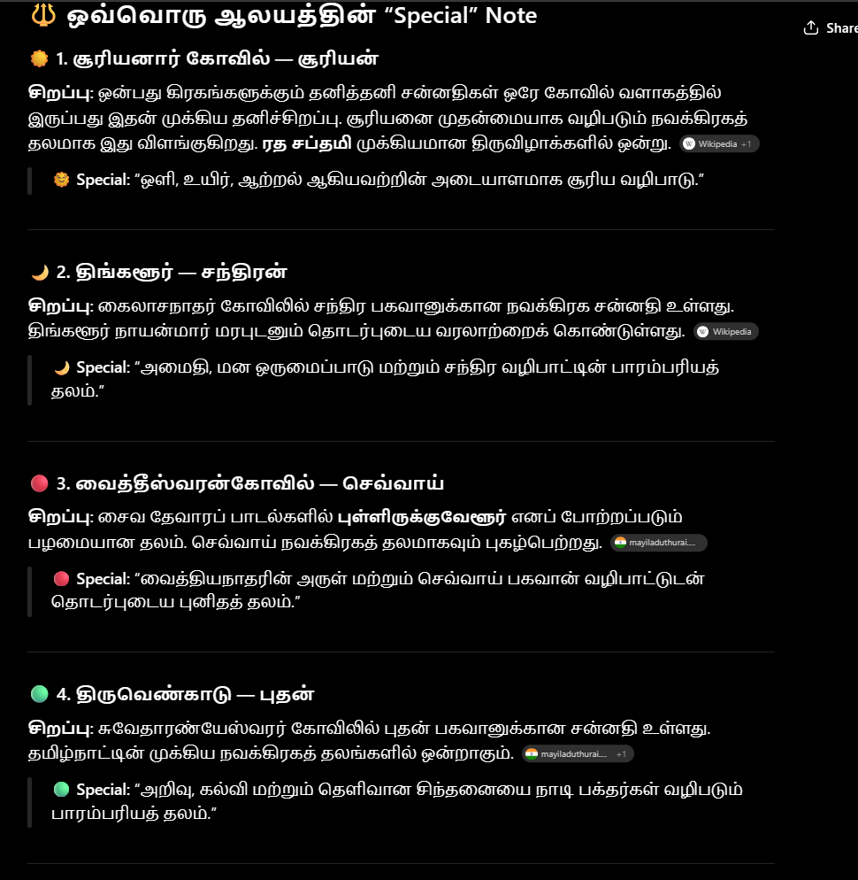

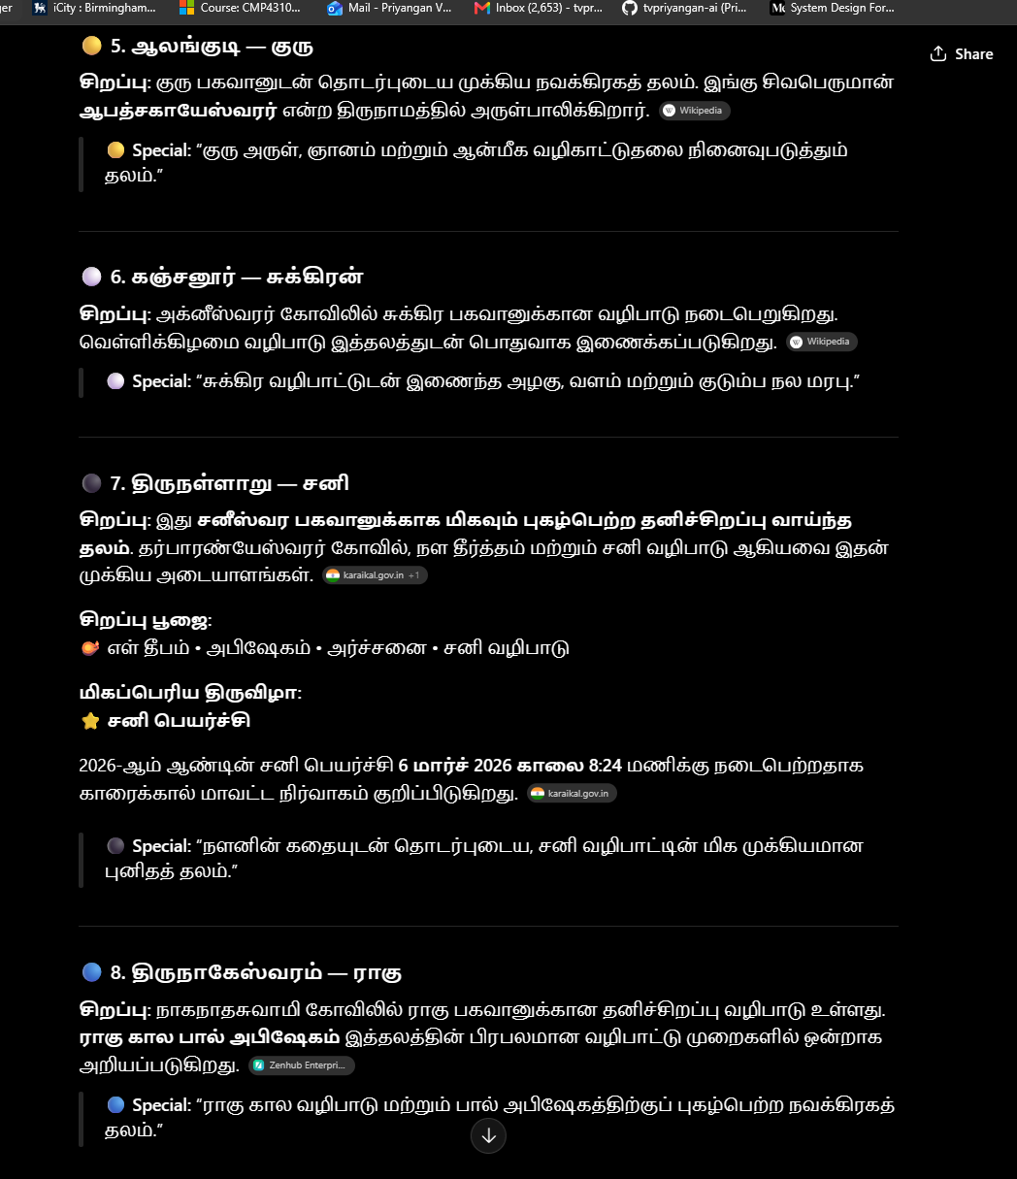

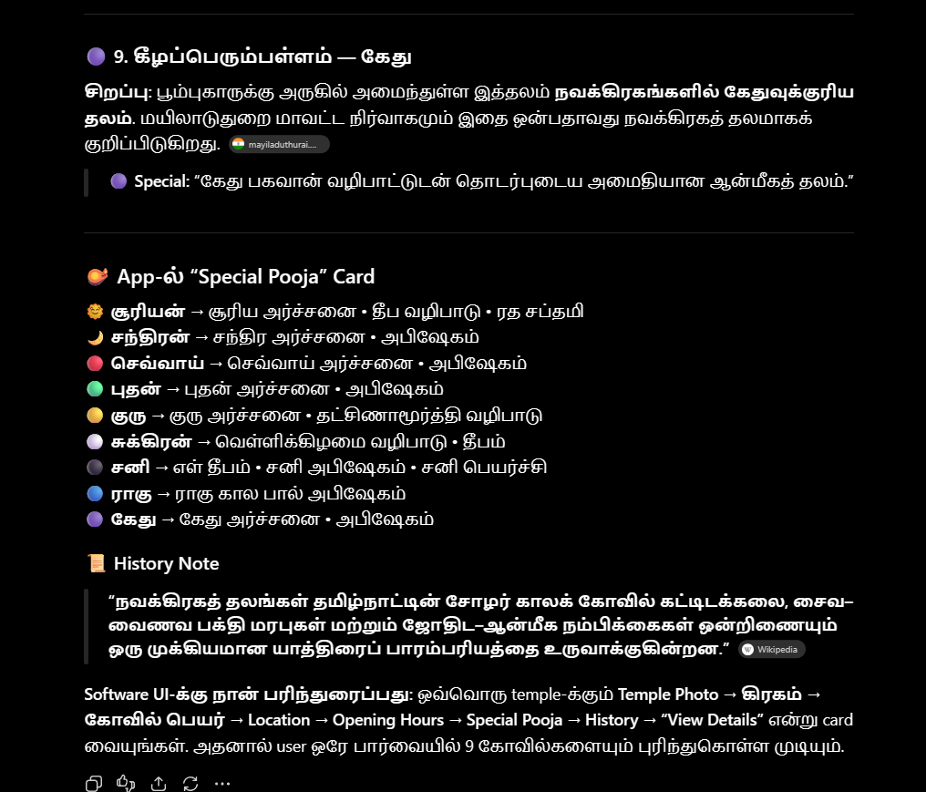

If anyone click this option, immediately show these details below.ok. and also attach some meditation related links also there, I will provide all.ok.
jpahdk;
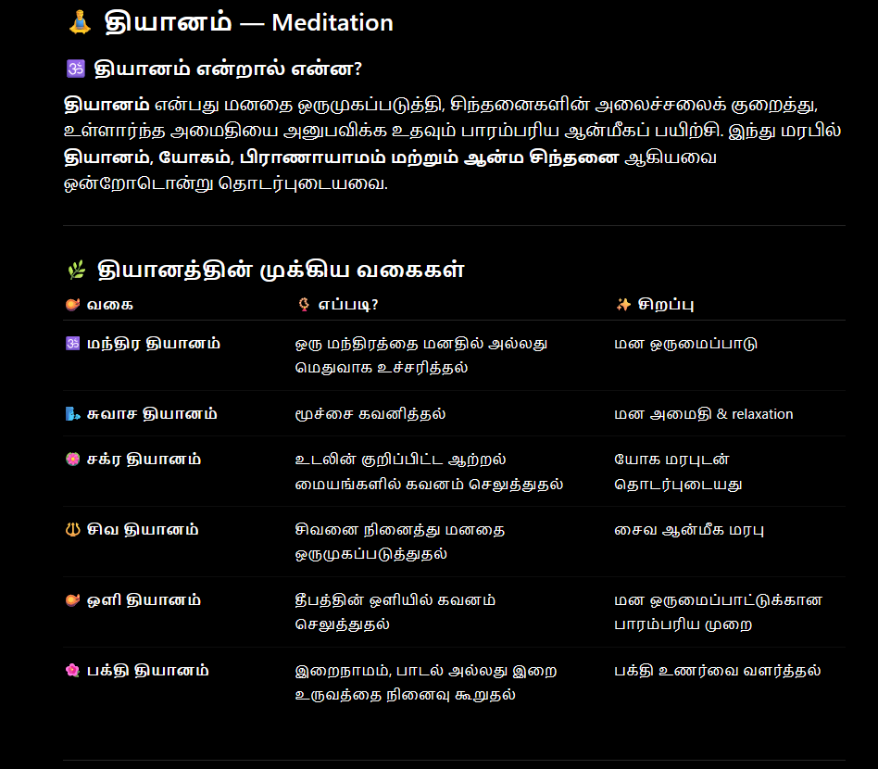
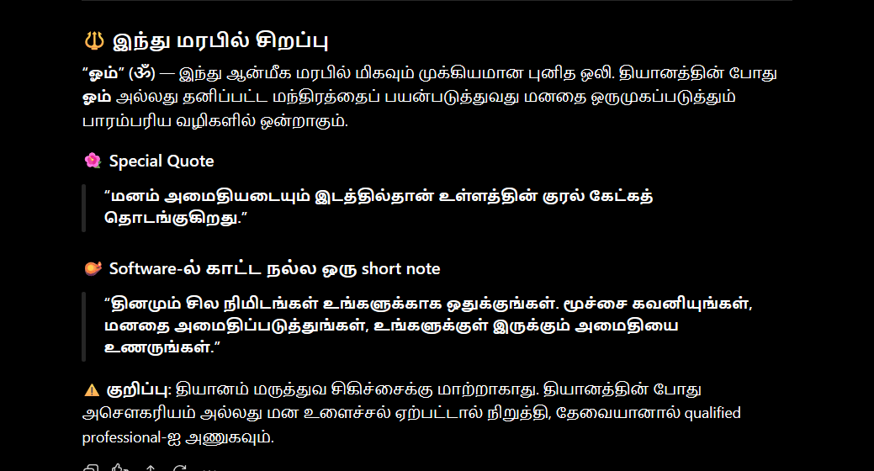
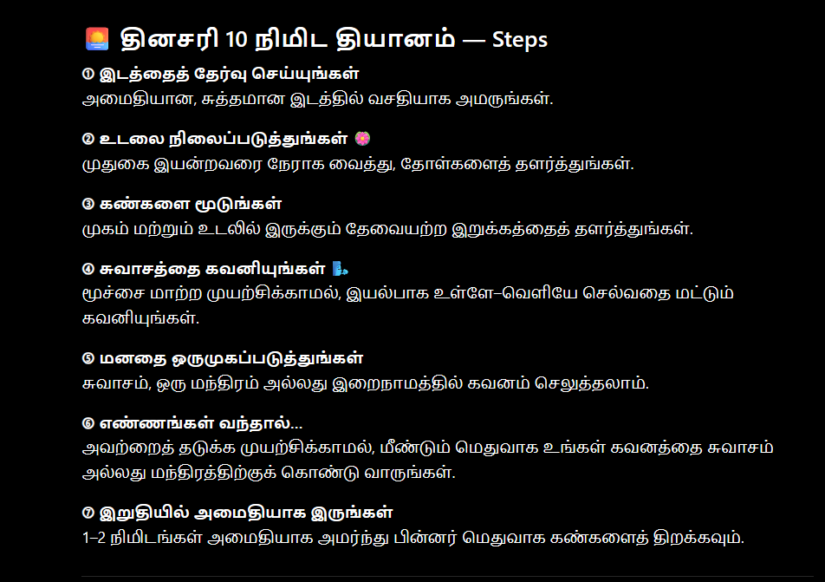

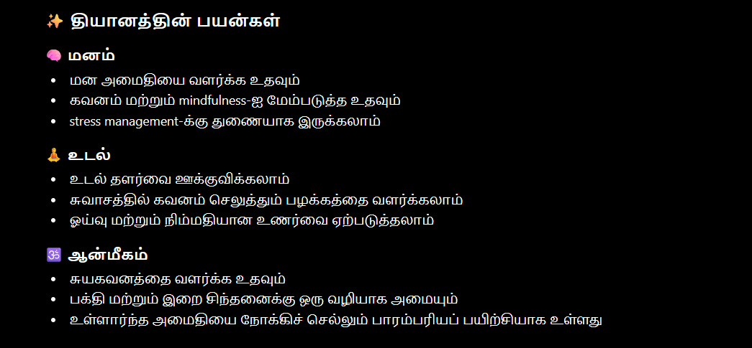

Nahfh
If anyone click this option, immediately show these details below.ok. and also attach some yoga related links also there, I will provide all.ok.
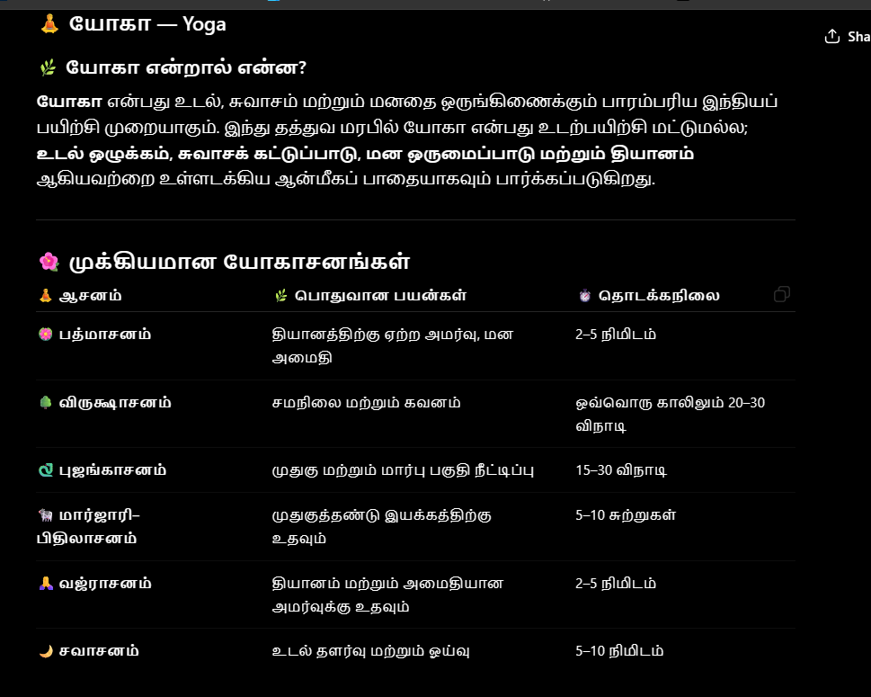
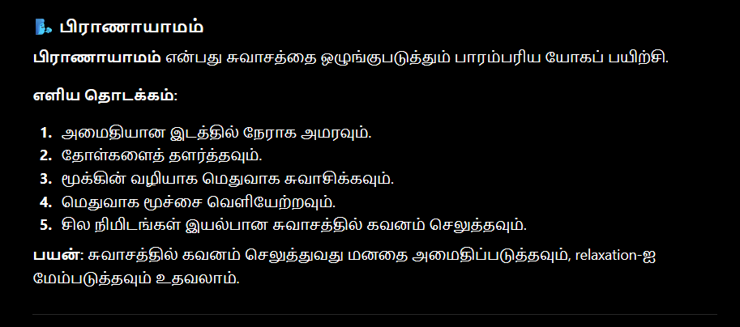
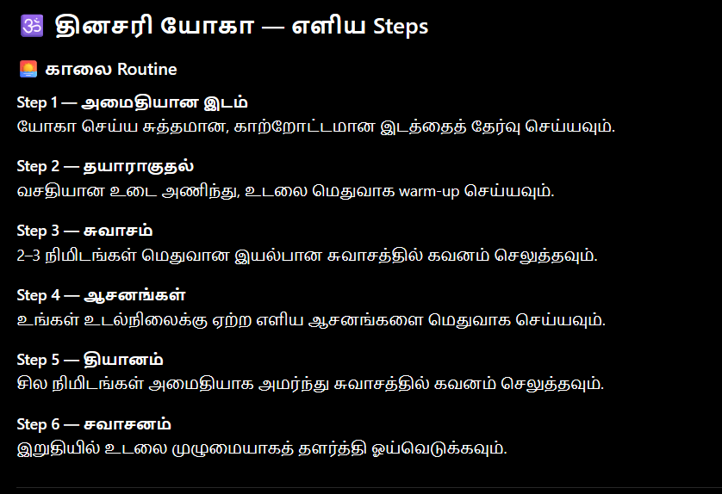
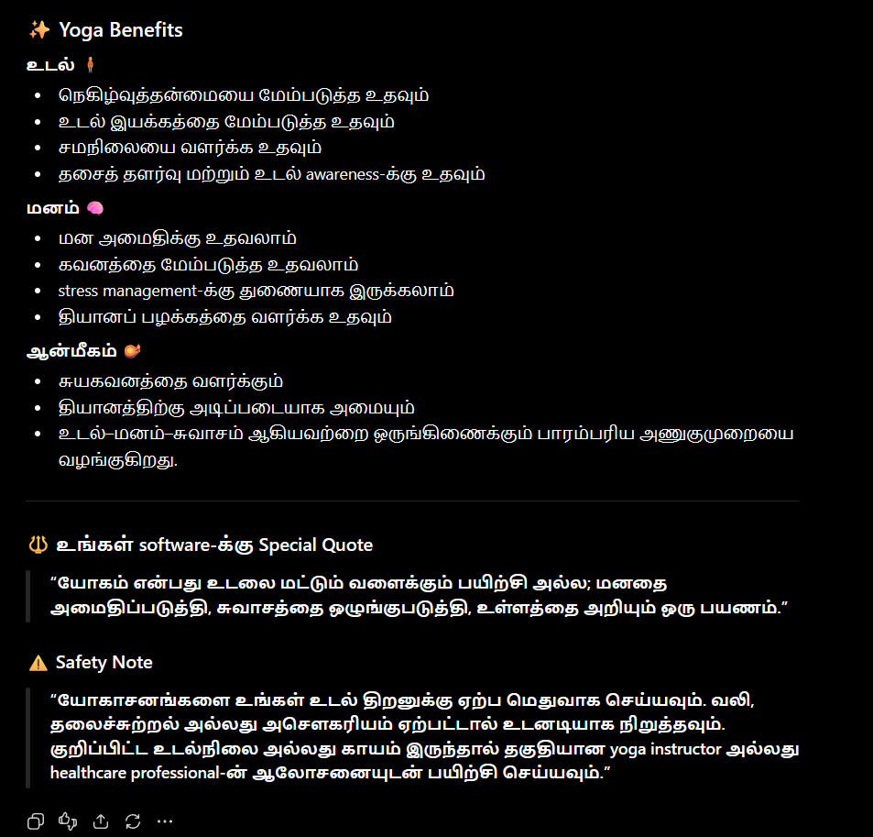

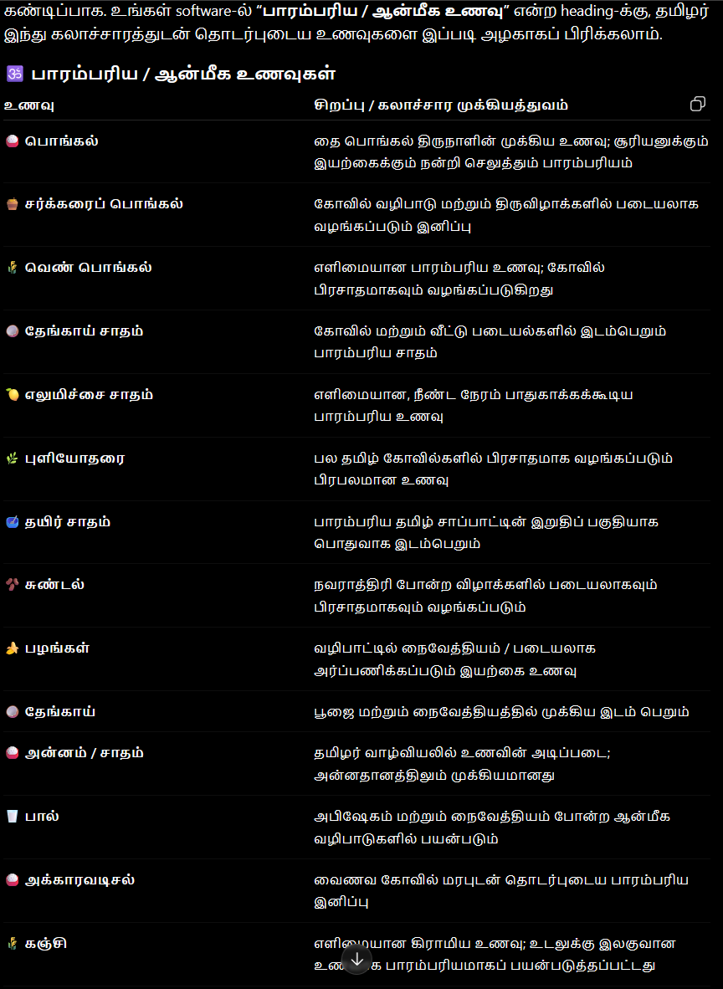
If anyone click this option, immediately show these details below.ok. and also attach some food and benefits and advantages of that food related links also there, I will provide all.ok.
czT

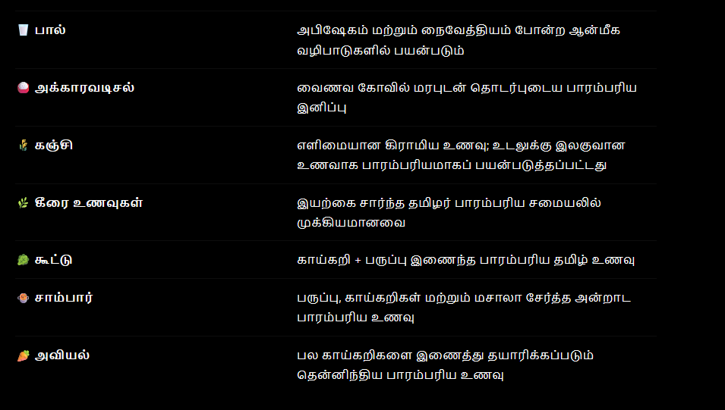

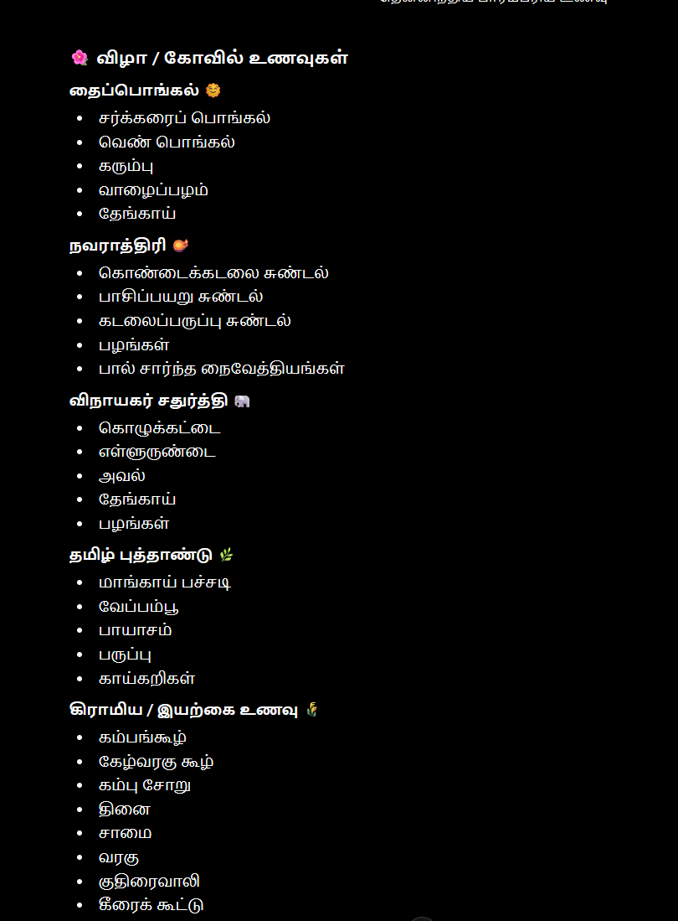

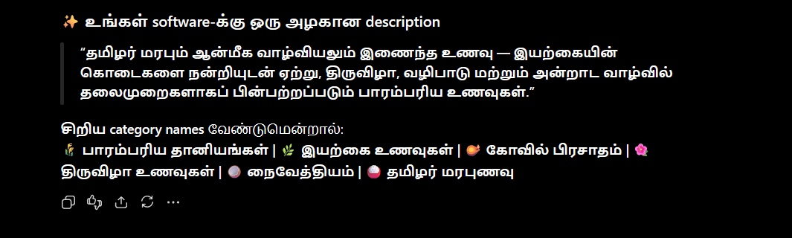

th];J

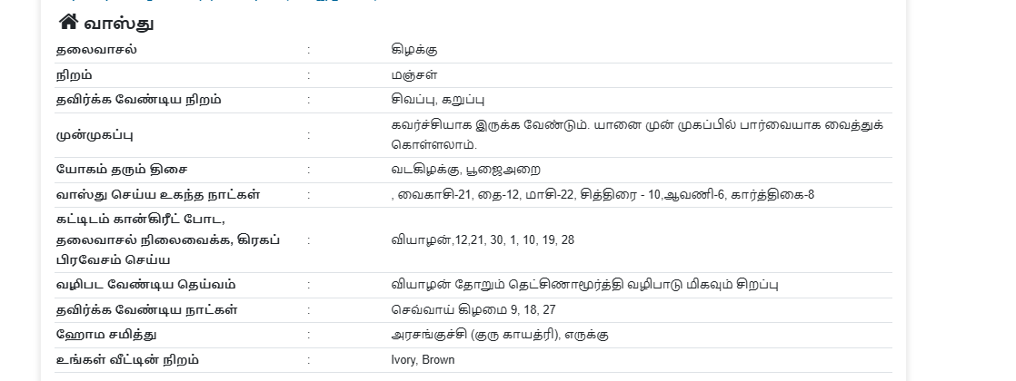
this chapter shows personal vaasthu report for this user only, each user get a individual vaastu prediction according their raasi, nadsaththira, number. Ok. So use the calculated jathagam and show the genuine vaasthu report.
MAs;Ntjk;

If anyone click this option, immediately show these details below.ok. and also attach some aayulvedam related links also there, I will provide all.ok.
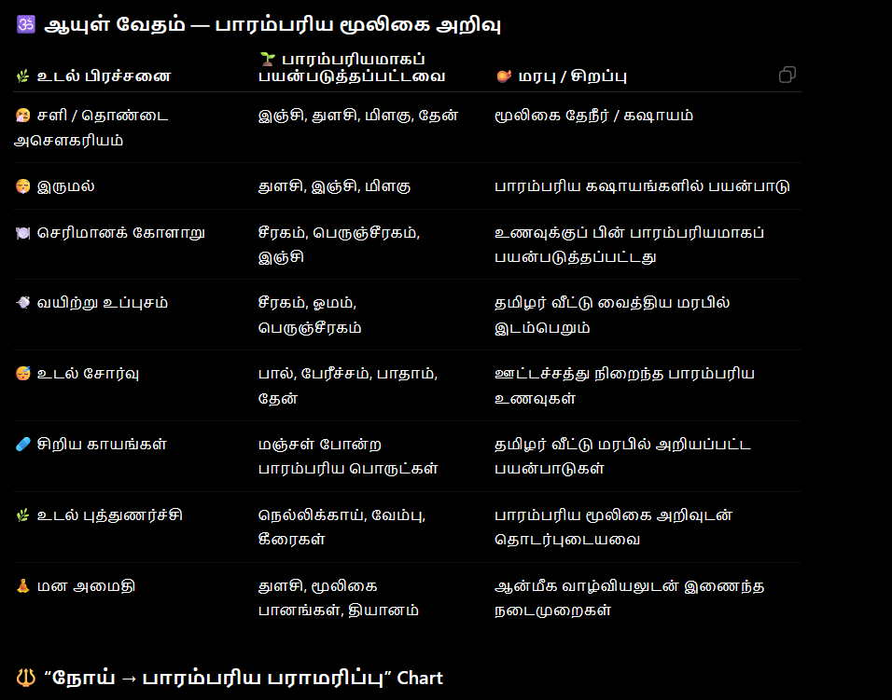

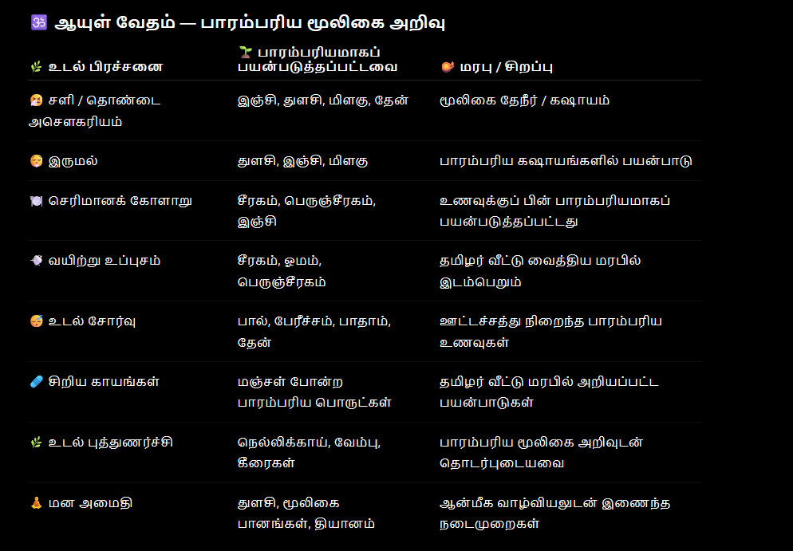

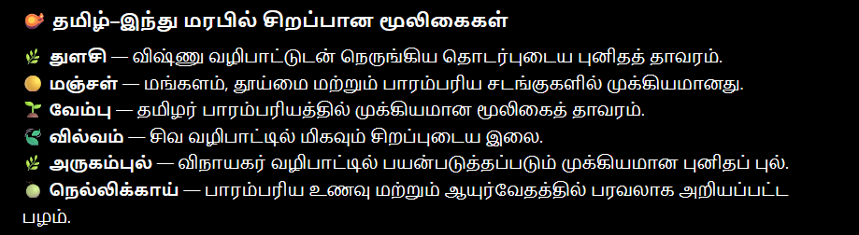

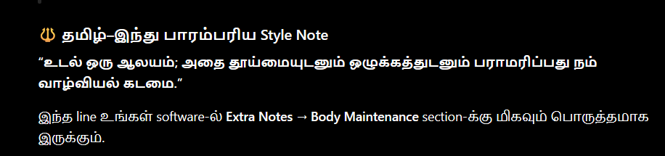
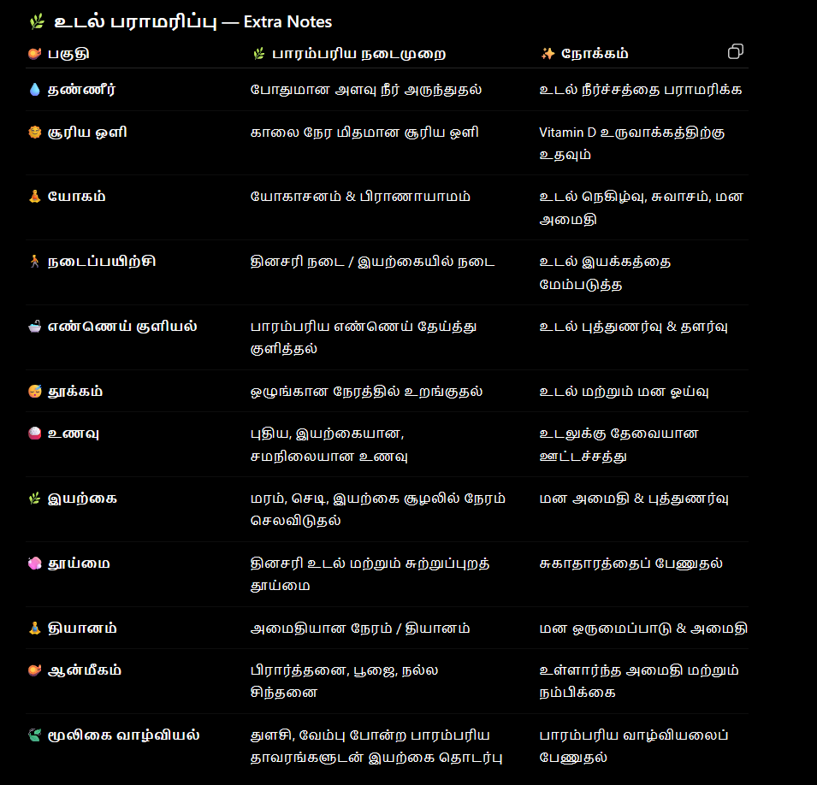
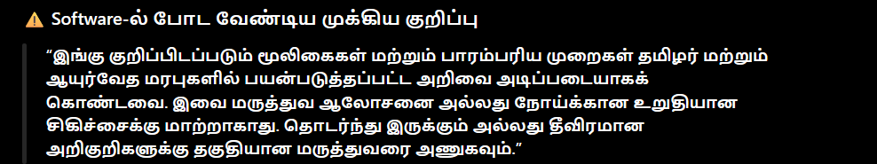
Gj;jfq;fs;

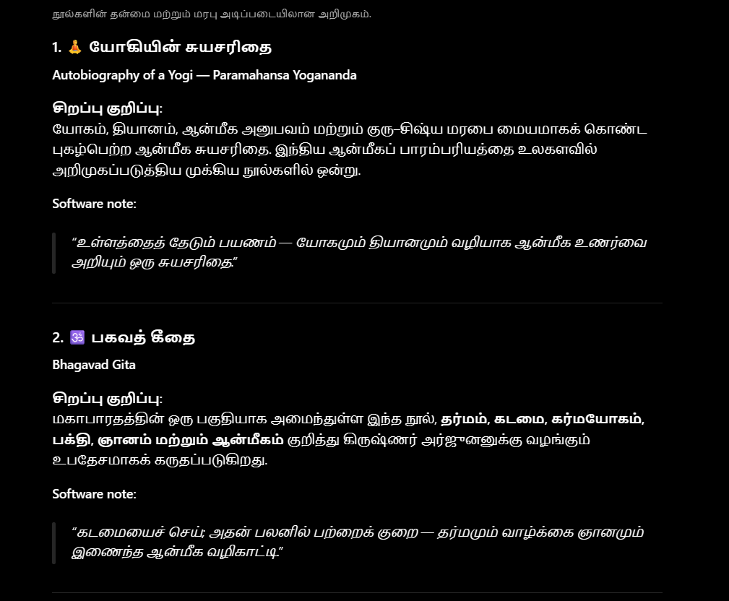
If anyone click this option, immediately show these details below.ok. and also attach some books related links also there, I will provide all.ok.

